###### 1 OVERVIEW

1.1 **Business Goals**

The business goal of the system is to sell products online. The products detail will be uploaded to the system by vendors. It also allows vendors to modify their products information. Customers can search for a product and order it by paying using VISA/MASTER card.

1.2 **Business Process Overview**

The use case diagram below shows the main overview of the business processes and interaction between stakeholders.

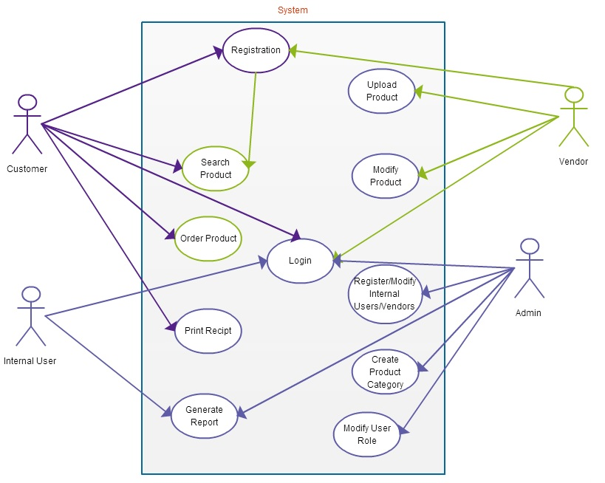

**1.3** **Objectives of System**

The main objectives of the system are:

* To order products online
* Add/modify products information by vendors
* Send order confirmation(receipt) and invoice for customer
* Generate reports

**2 BUSINESS PROCESS**

2.1 **Process map**

#### Order Management Process

|  |  |
| --- | --- |
| Customer | Submit Order  Select Product  Search Product |
| paymentGateway | Process Payment |
| myCompany.com | Generate Receipt/Invoice |
| MyFinance.com | Fund Transfer |

2.2 **Business Functions**

The main business functions of the system.

* Customer registration
* Vendor registration (approved by admin)
* Upload products info. (by vendors)
* Search a product
* Order product
* Payment using VISA/MASTER card
* Generate reports, order confirmation(receipt) and invoice.

3 BUSINESS FUNCTIONS

3.1 **Functional Requirements**

Business function: Shopping Cart Module

Description of the function

This process is one of the core processes of the system that enables customer to select product, pay using credit or debit card and finally print the receipt.

Roles

Customer, Payment Gateway, myFinance.com

Input

Search and add desired products to shopping cart

Output

Shopping cart with desired items and in desired quantity

Flow of Events

The following table shows the sequential flow of events :

a) Event Table

|  |  |  |
| --- | --- | --- |
| **Sequence No.** | Role’s Action | System Response |
| 1 | USER- Log in to the system | Authenticate the user and redirect to client’s home page (If the user is authenticated). If the user is not authenticated, display error message. |
| 2 | USER- Search for product | Search a product based on search text input of the customer and display all the products that match the search text. |
| 3 | USER- Add to cart | Add selected products to customer’s shopping cart |
| 4 | myFinance- Pay using VISA/MASTER card | Verify the customer’s card details and respond Y or N to show the status. |
| 5 | USER- Print receipt | Generate receipt as and sent to the customer by email. |
| 6 | USER- Log out from myCompany.com | Sign off the user from the system and deactivate the users session. |

1. Sequence Diagram

The sequence diagram shown below is for registered customer. The sequence diagram show the sequence events described above. Customer search for the product, add one or more products to the cart then finally pay for the products. An order confirmation or receipt will be sent to the customer.

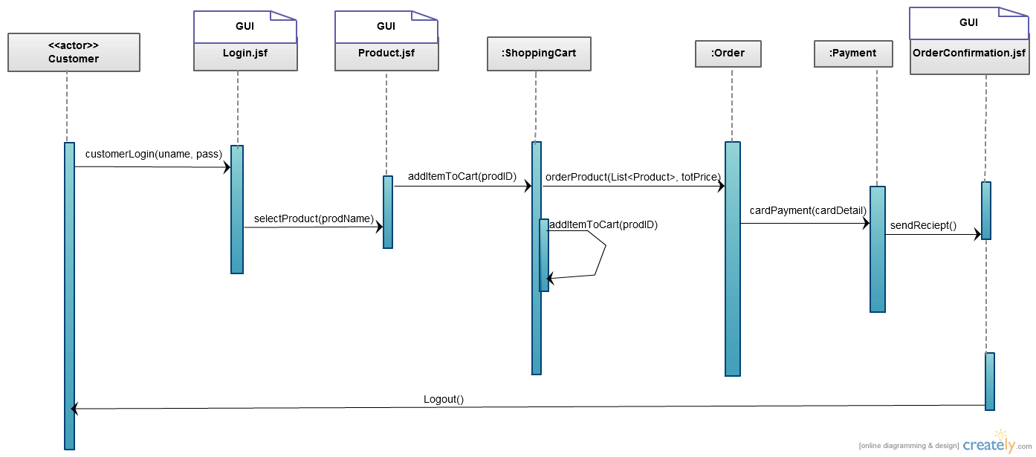

**4 OTHER REQUIREMENTS**

1. SECURITY REQUIREMENTS

- The system is role based, so all users should be assigned to one of the five roles (Customer, InternalUser, Admin, Vendor, Guest) at the time of registration

* **Payment transaction shall be secured using SSL**

1. EXTERNAL INTERFACES

* myFinance.com and paymentGateway

1. ARCHIVAL REQUIREMENTS

- Periodic backup of database will be taken to keep customers history and transactions.

1. CONTINGENCY REQUIREMENTS

- Tolerable downtime: uptime of 99.8%

- Replicate data across multiple regions

# 5 SYSTEM/OPERATING ENVIRONMENT

a) Hardware Requirements/Configuration

Amazon EC2 virtual instance on Amazon web services cloud

b) System Software

Ubuntu 14.04 LTS Server

Jenkins

Maven

Git

Java JDK 1.7

6 ASSUMPTIONS AND LIMITATIONS

**Assumptions**

* User credit amount will be inserted to the database automatically at the time of user registration.

*  Report, invoice and receipt printout format will be in “PDF”

*  There are 5 types of user roles namely “Admin”, “InternalUser”, “Vendor”, “Customer” and “Guest”

* Vendors will be able to insert their products into the system.

* Sold item revenue will be shared between the vendor and mycompany.com in 70:30 ratio.

* The admin will create product categories and internal users

7 USER INTERFACE DESIGN CONCEPT

* Background: White
* Screen layout
* Menu at top
* Categories on the left (when applicable)
* Search result main body(Center),
* User interactions
* Text font / style: 11 px. Arial font, Normal
* Header / Footer / Terms and Conditions: Yes, standard template will be used

###### 8 SCENARIO FLOW / USER INTERFACE DEMO

Business process: Order a product (for registered customer)

Customer

Guest

Is Registered User

Y

Y

N

Has Card Information

N

Print Receipt

Confirmation

Shipping Details

Payment Detials

Submit Order

Select Product(s)

Search Product

Login